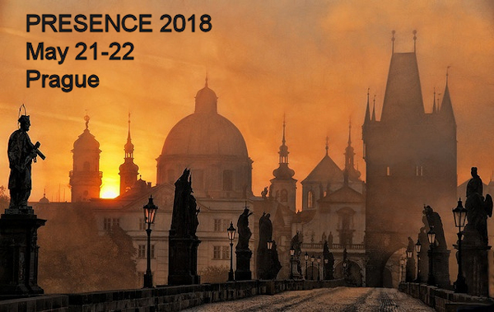

CALL FOR PAPERS

PRESENCE 2018
18th conference of the International Society for Presence Research (ISPR)
Prague, Czech Republic
May 21-22, 2018 (optional demonstrations and guided sightseeing events May 20)
https://ispr.info/call-presence-2018

Conference theme: Challenges

Submission deadline: February 20, 2018

OVERVIEW

Telepresence, often shortened to presence, is a state or perception in which we overlook or misconstrue the role of technology and feel present in the environments and/or connected to the people or things we experience via technology. It’s increasingly relevant to a wide range of media experiences and application areas.

Following a series of 17 successful Presence conference events (http://ispr.info/presence-conferences/previous-conferences/), PRESENCE 2018 will retain the single-track format and enjoyable social environment of previous conferences while featuring an expanded variety of paper and poster sessions, panel discussions, keynote presentations, hands-on demonstrations of presence applications/services/projects, and informal discussion, networking and fun. Members of both academic and industry communities are welcome.

At the end of the first day, all attendees are invited to a social dinner; we also hope you’ll join us for all or part of a day of demonstration visits and guided sightseeing on May 20 (the day before the conference).

The registration cost is $140, with a discounted student cost of $100. The fee includes lunches on both days, coffee and snacks during breaks, and the social dinner.

BACKGROUND AND OBJECTIVES

The term presence has many formal and informal meanings but is used by a growing interdisciplinary scholarly community to refer to experiences in which technology is overlooked or misconstrued in some way during a mediated experience. Long a focus of those who study virtual reality and environments, it’s increasingly relevant to a wide range of media experiences. For example, presence occurs when we get “lost” in the world of a novel, TV show, movie, video game or theme park ride; we’re convinced by the realism of paintings or graphic designs; we treat our cars, computers or other machines as if they have personalities of their own, and we feel like we’re “with” a person we talk to on the phone or in a video conference.

The presence research community has been working to identify causes, characteristics and consequences of diverse presence experiences. The consequences identified so far – including arousal/relaxation, empathy, enjoyment, persuasion and more – make clear the importance and power of presence to improve communication across a wide variety of contexts and applications of interest to scholars and those who create media technologies and content. Presence as a concept and set of phenomena is related to the work being done in nearly every field and business sector from art to zoology, with particularly direct applications in business, education, entertainment and health. The 4000+ posts in ISPR Presence News (http://ispr.info/posts) and thousands more on its predecessor, the presence-l listserv (listserv.temple.edu/archives/presence-l.html), along with the Presence Bibliography on the ISPR website (http://ispr.info), illustrate the breadth of presence applications, and the breadth, depth and value of presence scholarship.

The objectives of the conference are to deepen and update the knowledge of those already familiar with presence and introduce new scholars and practitioners to the centrality, pervasiveness, and value of presence phenomena, theory and research. The overarching goal is to help integrate and increase collaborative scholarship on presence.

SUBMISSIONS

Topics
We seek original, high quality papers and demonstrations that contribute to our collective understanding of presence phenomena and applications in any/every aspect of life. Topics of interest include (but are absolutely not limited to):
- Presence theory
- Measures of presence
- Presence and emotion
- Presence and education
- Presence and social interaction
- Gender and Presence
- Neuroscience approaches to Presence
- Presence in gaming and entertainment
- Philosophical perspectives on presence
- Ethics of presence
- Presence technologies and applications (e.g. in business, arts, medicine and therapy)
- The future of presence research

Theme: Challenges
Researchers, scholars, technology designers and users, and citizens all face challenges related to presence. We invite submission in all of the categories below that identify, consider and ideally propose solutions to the challenges people in any or all of these groups face now or will face in the future. Data-based projects, concept and theory building work as well as personal (first person) reflections are encouraged.

Categories
We invite researchers and practitioners to submit their work in the categories below. All submissions are to be in APA format (http://www.apastyle.org) and except for the separate title page not identify the author(s) directly or indirectly (for blind peer review).
- PAPERS: Comprehensive descriptions of research or design work and/or theoretical investigation within the scope of the conference; up to 30 pages (including references) in APA format. Papers must relate to existing literature on presence and make an original contribution to it.
- SHORT PAPERS: Short papers may be up to 12 pages in APA format.
- POSTERS: Visual display presentations. Poster proposals must describe and/or contain early drafts of the visual display. Accepted poster abstracts will be displayed during a dedicated session of the conference that begins with short oral previews, and then published in the conference Proceedings.
- DEMONSTRATIONS/EXHIBITIONS: Step-by-step audiovisual demonstrations and/or hands-on experiences of non-commercial work within the scope of the conference. Accepted demonstration/exhibition proposals will be presented during a dedicated session of the conference and included in the conference Proceedings. For the exhibitions of commercial products, please contact us for sponsorship terms and opportunities.
- PANELS: Presence 2018 welcomes panel proposals which allow panelists and participants to discuss any topic relevant to presence, especially the conference theme of challenges. Discussion and paper panel submissions must include the following: (1) title, (2) description and rationale (75 words or less), (3) titles and brief abstracts (100 words or less) for each panelist, and (4) a complete list of participants along with their institutional affiliations and contact information.

Proceedings
All accepted submissions will be collected in the official conference proceedings (with ISBN) and will be permanently available for download in the ISPR conference archive.

Procedure
Online submissions should be submitted via EasyChair (https://easychair.org/conferences/?conf=p2018).

IMPORTANT DATES

Submission deadline: February 20, 2018
Notification of acceptance decisions: March 9, 2018
Finished, camera-ready papers due: April 20, 2018

REGISTRATION

Registration is $140, with a discounted fee of $100 for students. The fee includes lunches on both days, coffee and snacks during breaks, and the social dinner. An online registration system will be available soon.

Late registration at the event will cost $180 ($130 for students).

Venues for the optional demonstrations and guided sightseeing activities on May 20 will be selected to limit additional expenses.

LOCATION/VENUE

The conference will take place at Hotel Ambassador - Zlata Husa (http://www.ambassador.cz/default-en.html) in Prague, Czech Republic. The venue has much to offer:
- It’s located on the famous Wenceslas Square pedestrian area
- It offers a combination of wonderful historic buildings, exclusive traditional restaurants, modern bars and retail stores
- Within walking distance from the Hotel there are a number of theaters, museums and other important and historical monuments and attractions in the heart of Prague
- It’s easily accessible via local public transport
- Interesting locations nearby include City Centre, Old Town Square (Astronomical clock), Bethlehem Chapel, Charles Bridge, Alfons Mucha Museum, National Museum, National Theatre

TRANSPORTATION

- Airport information (http://www.pragueairport.co.uk/)
- LEO Express trains and buses (https://www.le.cz/i.php)
- U-tube station Můstek is 100 m from conference site
- Tram station (Václavské náměstí) is 250 m from conference site
- Masaryk Train Station is 900 m from conference site

ACCOMMODATIONS

The conference won’t provide housing but there are many good options for accommodations near the conference venue, including these:
- The conference site: Hotel Ambassador - Zlata Husa (http://www.ambassador.cz/default-en.html)
- Hotel Prague Inn (http://www.hotelpragueinn.cz/EN/poloha-hotelu)
- Prague Marriott Hotels International (http://www.marriott.com/hotels/travel/prgdt-prague-marriott-hotel/)

DEMONSTRATIONS AND SIGHTSEEING May 20, 2018

On Sunday May 20 from 11 am until 5 pm attendees are invited to join us for guided demonstration visits and sightseeing. Just a few potential stops on a tour to be led by conference team members include the places listed above under Location/Venue as well as...

Prague astronomical clock (http://www.staromestskaradnicepraha.cz/cs/prazsky-orloj/)
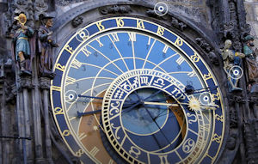

Franz Kafka's Head kinetic sculpture by David Černý (http://www.thisiscolossal.com/2016/05/a-rotating-42-layer-sculpture-of-franz-kafkas-head-by-david-cerny/)
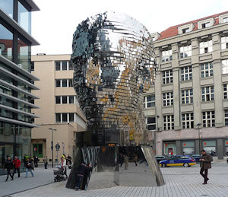

VR Dimension (http://vrdimension.cz/zazitky/) and Torch VR (http://www.torchvr.cz/)
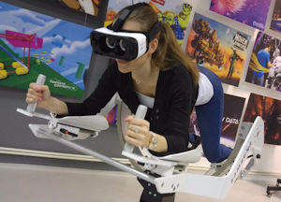

National Technical Museum (http://www.ntm.cz/en/en-muzeum)
(or some of Prague's 11 Weirdest Museums)
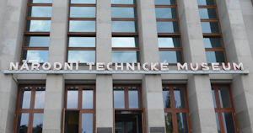

Prague Ghosts Tour (http://www.tourhistory.cz/en.html)
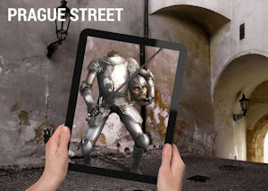

Nuclear shelter vent turned into R2D2 (http://www.bbc.com/news/blogs-news-from-elsewhere-41735261)

ABOUT ISPR

The International Society for Presence Research (ISPR) is a non-profit membership organization founded in 2002 to support academic research related to the concept of (tele)presence.

ISPR has sponsored 17 successful international conferences (beginning informally in 1998), providing richly social opportunities to share scholarship and applications of the presence concept.

The ISPR website (http://ispr.info) serves as a resource for those who conduct research, develop theory, design, market, write about, or simply are interested in, the concept and phenomena of presence.

ISPR Presence News (http://ispr.info/posts), available via the ISPR website, provides current news stories, calls for papers and participation, position announcements, and other informative posts every weekday (a total of nearly 4000 posts since 2009).

ORGANIZERS and CONTACT

Matthew Lombard, Temple University (lombard@temple.edu)
Cheryl Bracken, Cleveland State University
Jihyun Kim, University of Central Florida
SongYi Lee, Temple University
Emil Steiner, Temple University
Kun Xu, Temple University
Hocheol Yang, Temple University

